**DAILY ONLINE ACTIVITIES SUMMARY**

|  |  |  |  |  |  |  |
| --- | --- | --- | --- | --- | --- | --- |
| **Date:** | | | **10/06/2020** | **Name:** | **JASLINE SHARON TAURO** | |
| **Sem & Sec** | | | **4th sem, A Section** | **USN:** | **4AL18CS029** | |
| **Online Test Summary** | | | | | | |
| **Subject** | **OBJECT ORIENTED CONCEPTS** | | | | | |
| **Max. Marks** | **30** | | | **Score** | **24** | |
| **Certification Course Summary** | | | | | | |
| **Course** | | | **Introduction to Information Security** | | | |
| **Certificate Provider** | | **Great Learning** | | **Duration:** | | **3 HRS** |
| **Coding Challenges** | | | | | | |
| Problem Statement:Write a C Program to rotate the matrix by K times.Write a C Program to print the sum of boundary elements of a matrix.Write a Java Program to find the longest repeating sequence in a string. | | | | | | |
| **Status: DONE** | | | | | | |
| **Uploaded the report in GitHub** | | | | **YES** | | |
| **If yes Repository name** | | | | <https://github.com/jaslinesharontauro/JAVA_Prgms>  <https://github.com/jaslinesharontauro/C_Prgms> | | |
| **Uploaded the report in slack** | | | | **YES** | | |

**Online Test Details: (Attach the snapshot and briefly write the report for the same)**

**Certification Course Details: (Attach the snapshot and briefly write the report for the same)**

**Coding Challenges Details: (Attach the snapshot and briefly write the report for the same)**

**1.ONLINE TEST DETAILS:**

**Today we had assessment in the subject OBJECT-ORIENTED CONCEPTS. The test was based on SECOND and THIRD module of this subject. There were total 15 number of questions of TWO mark each, out of which I scored 24.**

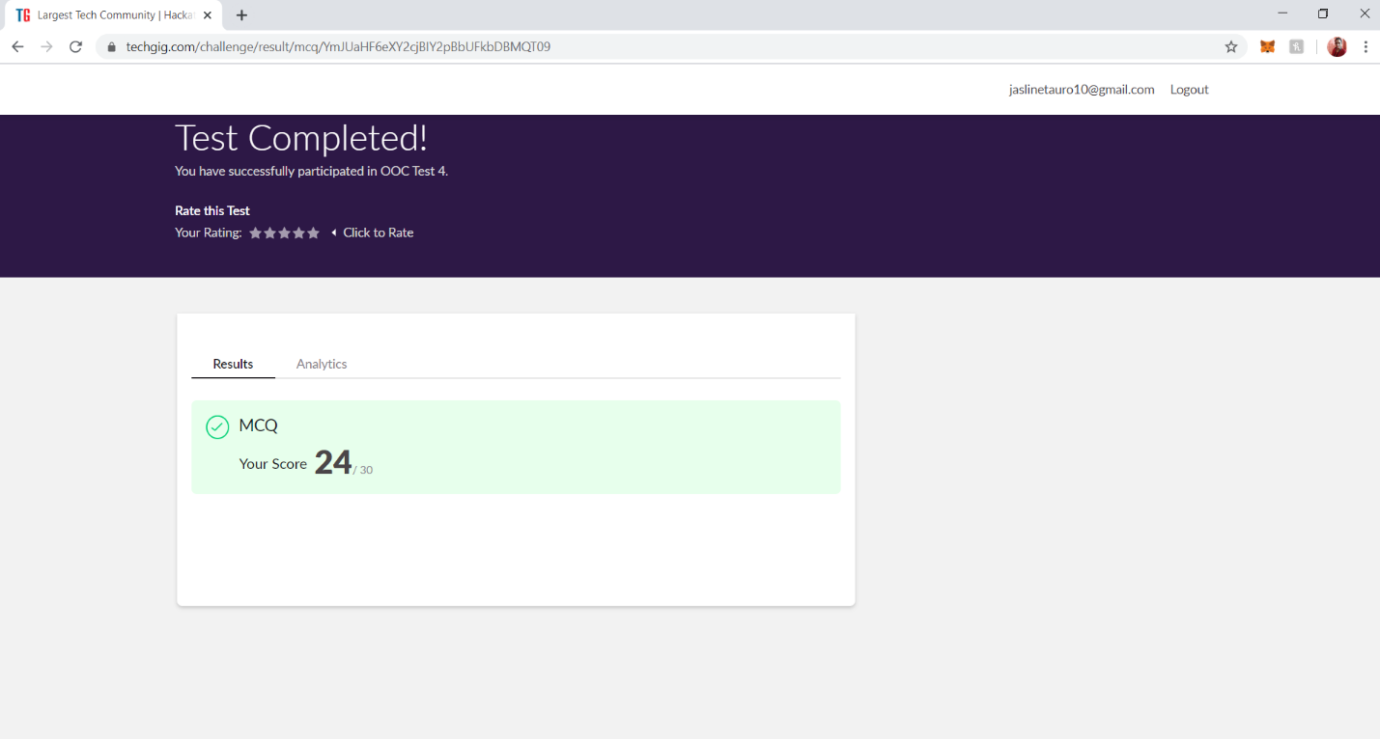

**2.CERTIFICATION COURSE DETAILS**

**Today I have done certification course INTRODUCTION TO INFORMATION SECURITY by GREAT LEARNING ACADEMY. This course is based on basic concepts of Information Security.** This course covers the application security and software security and examines what can be done in the pre-deployment phase to secure software systems.

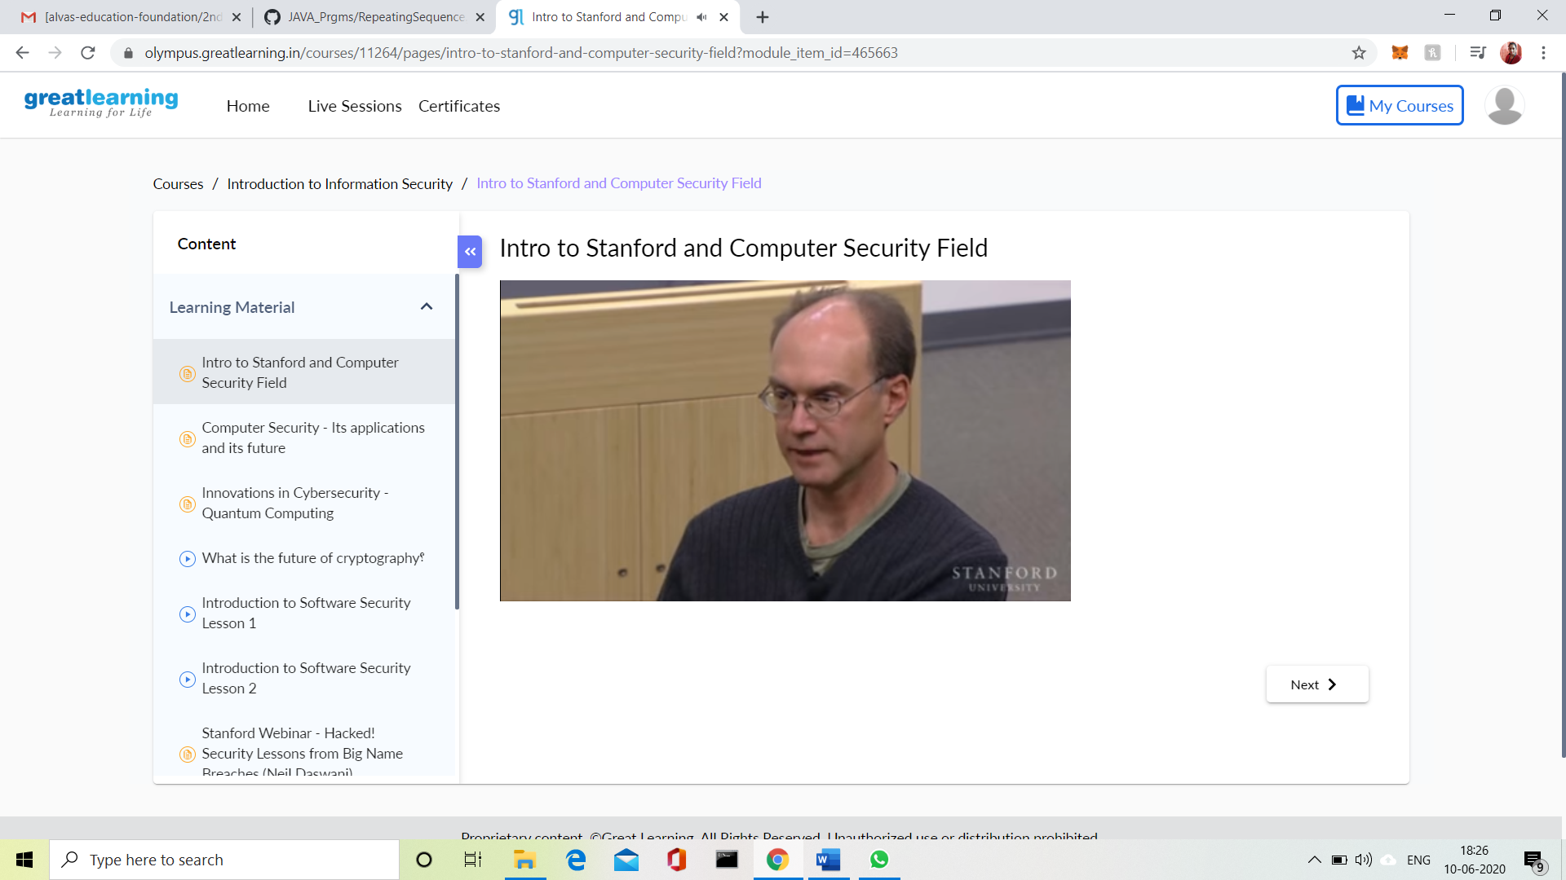

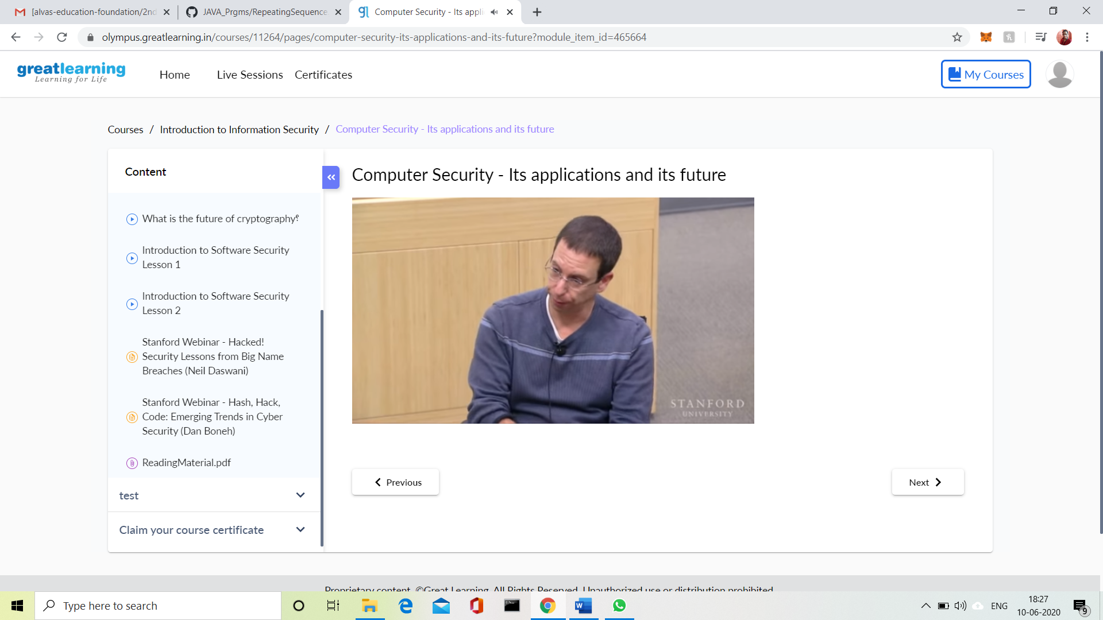

**3.CODING CHALLENGES DETAILS:**

**Problem statement 1:**

Write a C Program to rotate the matrix by K times.

Rotate the matrix by K times means rotating the given NN matrix to the specified (K) number of times. For example, consider the 33 matrix, which has to be rotated once,  
Enter the Size of the Matrix: 3, 3  
Enter the Elements of the Matrix: 10, 20, 39, 40, 50, 60, 70, 80, 90  
Enter the value of K (Number of Rotations): 1  
Matrix before Rotation:  
10 20 30  
40 50 60  
70 80 90  
Matrix after Rotation:  
20 30 10  
50 60 40  
80 90 70

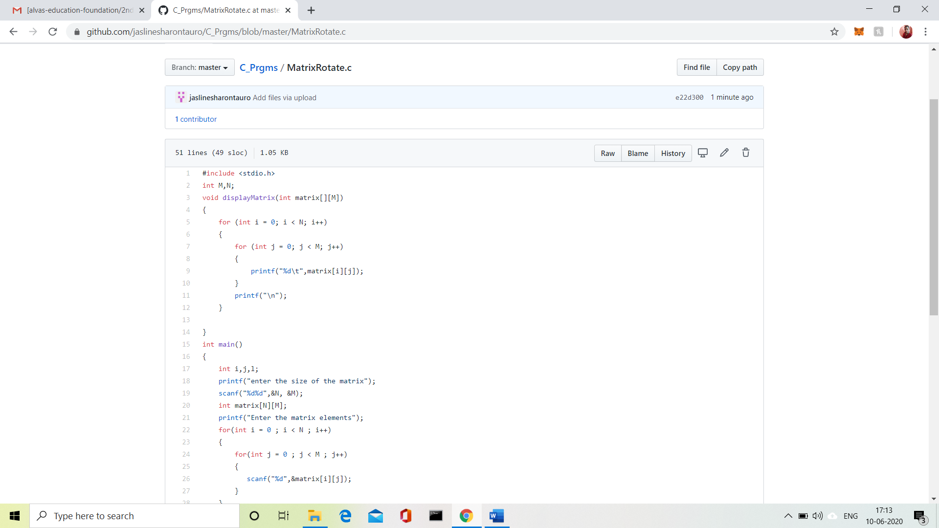

SOLUTION UPLOADED IN GITHUB

Problem Statement 2:

Write a C Program to print the sum of boundary elements of a matrix

Given a matrix, the task is to print the boundary elements of the matrix and display their sum.  
Sample Output 1:  
Enter M (Rows) and N (Columns): 3, 3  
Enter the Elements: 1 2 3 4 5 6 7 8 9  
OUTPUT:  
The Input Matrix is:  
1 2 3  
4 5 6  
7 8 9  
The Boundary Elements are: 1 2 3 4 6 7 8 9  
The Sum of Boundary elements of the Matrix is: 40

Sample Output 2:  
Enter M (Rows) and N (Columns): 4, 5  
Enter the Elements: 1 2 3 4 5 6 7 8 9 10 11 12 13 14 15 16 17 18 19 20  
OUTPUT:  
The Input Matrix is:  
1 2 3 4  
5 6 7 8  
9 10 11 12  
13 14 15 16  
17 18 19 20  
The Boundary Elements are: 1 2 3 4 5 8 9 12 13 16 17 18 19 20  
The Sum of Boundary elements of the Matrix is: 147

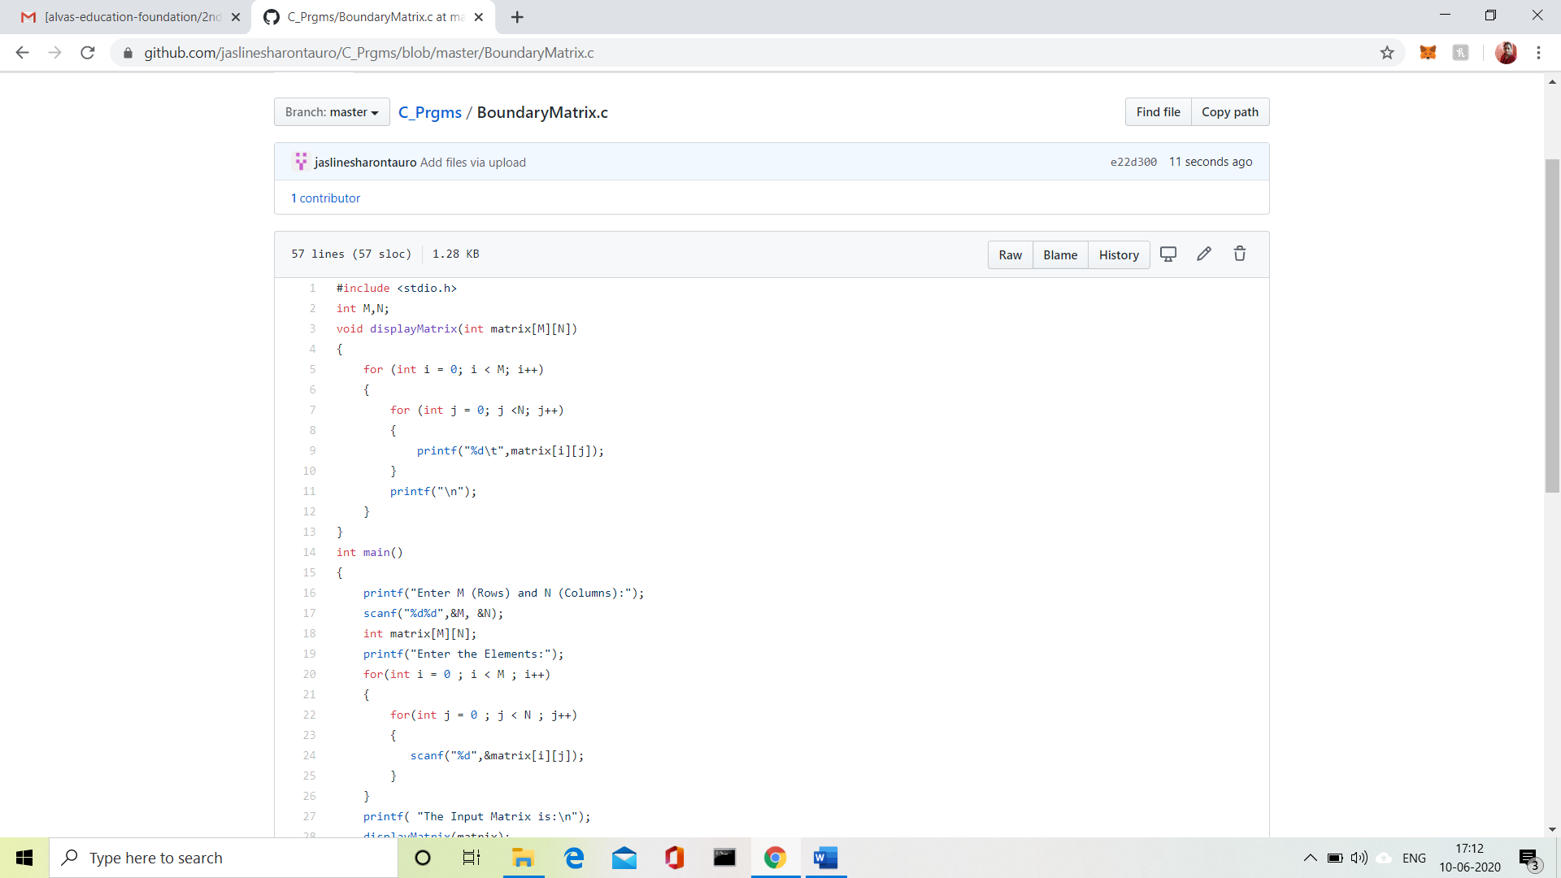

SOLUTION UPLOADED IN GITHUB

**Problem Statement 3:**

Java Program to find the longest repeating sequence in a string  
string: acbdfghybdf

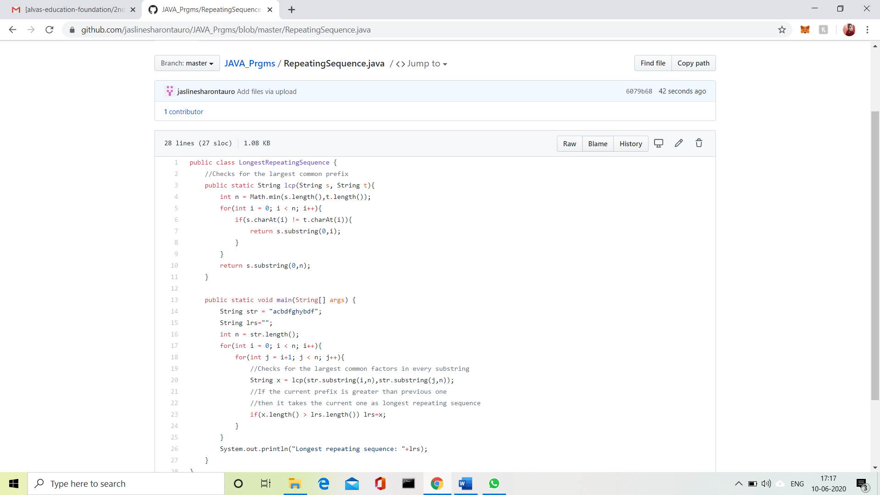

**SOLUTION UPLOADED IN GITHUB**